National Association of Superintendents
Naval Shore Establishments
Pearl Harbor Naval Shipyard and IMF Chapter
Pearl Harbor, Hawaii

Aloha Fellow NAS Members.

The Pearl Harbor Chapter started the New Year with our installation banquet on January 15, 2011 to recognize the outgoing and new Executive Board members. Admiral R. Berkey (U.S. Pacific Fleet Maintenance Officer, N43) was the keynote speaker and spoke about the NAS Superintendents needing to be the leaders for our Shipyard and to continue leading our string of recent successes. The new Executive Board (Clem Lopez - President, Bill Sullivan – Vice President, Dan Yamane – Secretary, Bob Myers – Treasurer, and Nate Lorenzo –Master at Arms) is energized and our focus will be in following areas: Alignment on Project Performance, Improvement in the Training Program, and Succession Planning for Key Shipyard Positions.

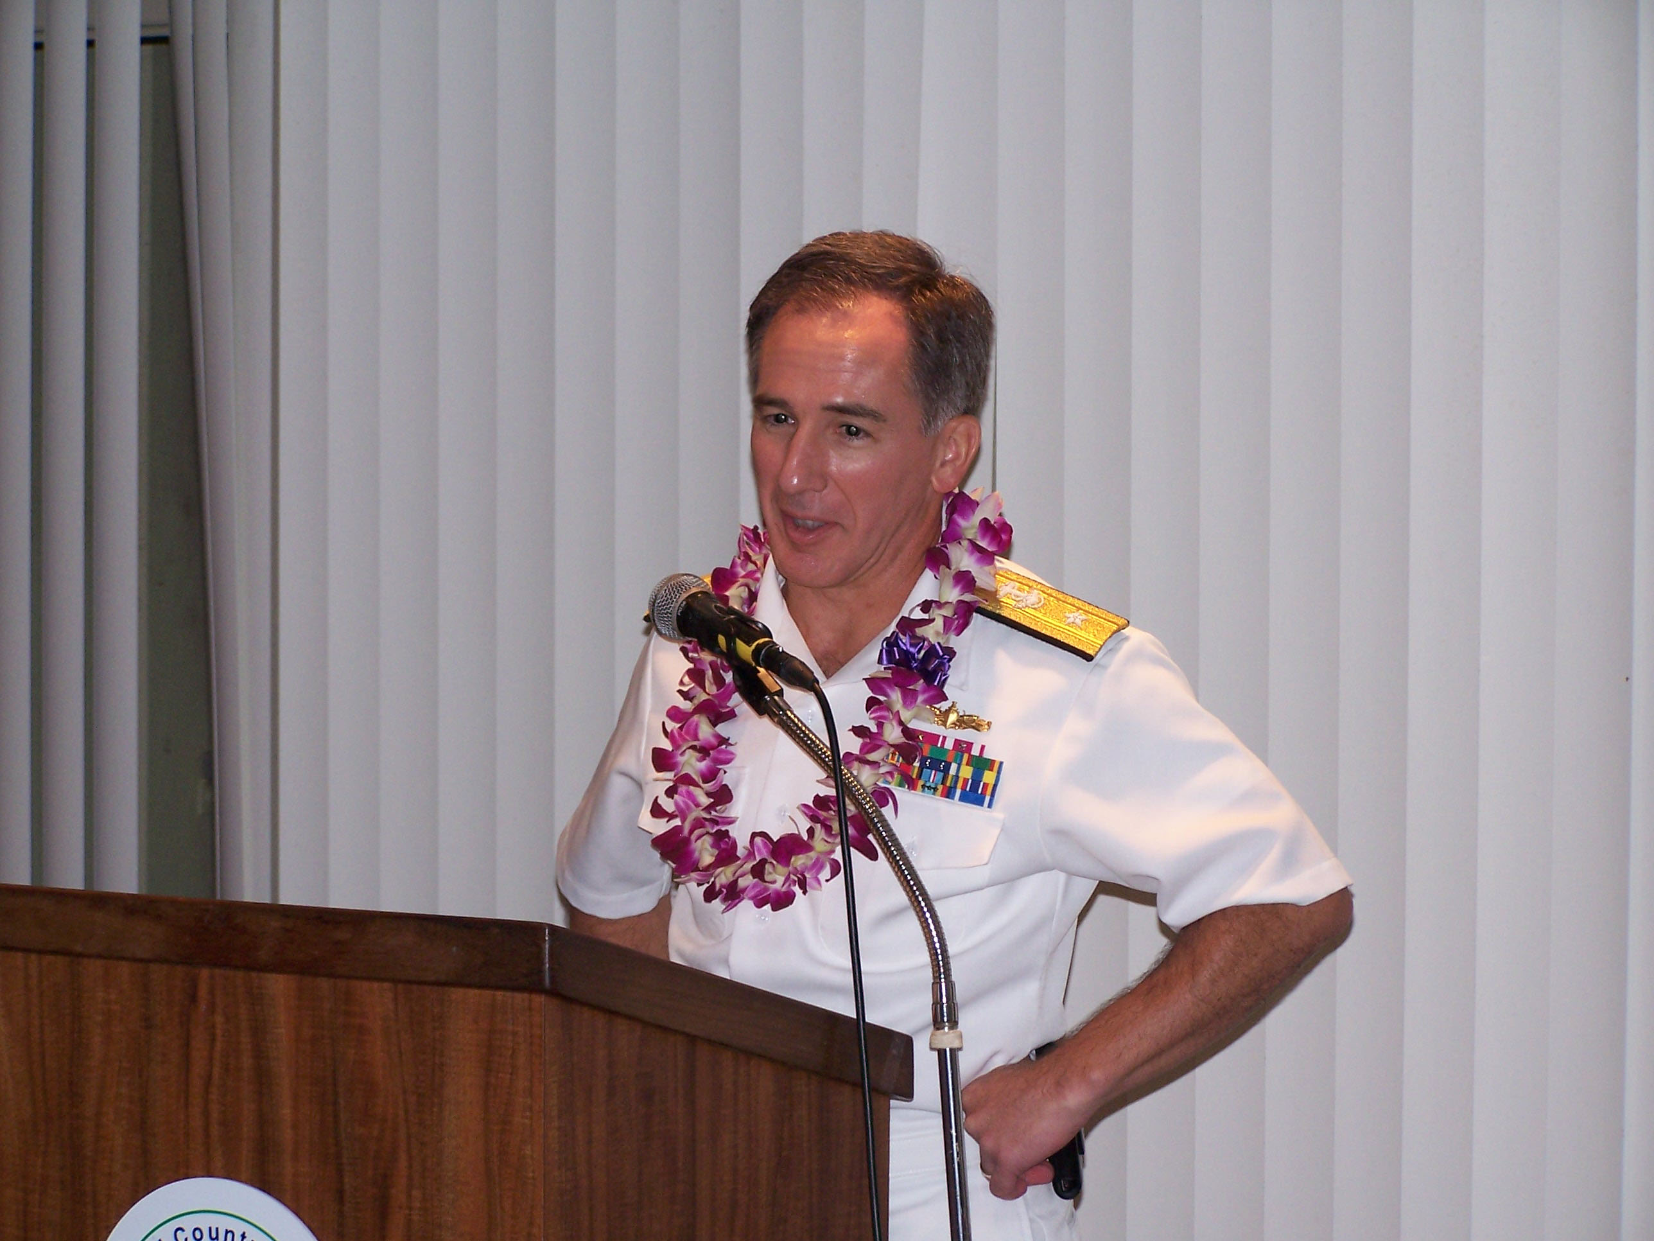

2011 NAS Installation Banquet Keynote Speaker,
Admiral R. Berkey, U.S. Pacific Fleet Maintenance Officer, N43
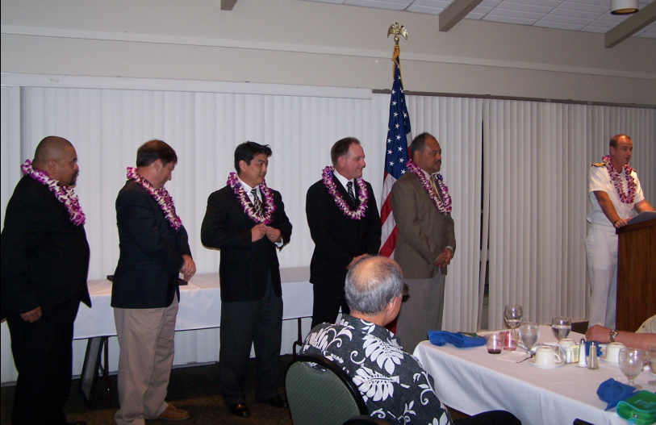

Installation of the 2011-2012 NAS E-Board for the Pearl Harbor Chapter
by the Installing Officer,
Captain Brian Osgood, Commander, Pearl Harbor NSY & IMF

We continue to have a significant workload across the waterfront. The USS CHICAGO (EOH) under Project Superintendent Joe Mendonsa’s leadership was able to undock six weeks early and is presently working toward the next key event. Joe is challenging his team to achieve an early project completion date. Project Superintendent Nate Lorenzo continues to demonstrate his leadership abilities by his team’s commitment to the lean implementation initiatives and their ability to utilize the tools and methods to mitigate issues on the USS KEY WEST (EOH).

In the DSRA arena, the USS COLUMBUS under Project Superintendent Miles Kotoshirodo’s guidance, undocked in December and continues pushing hard to complete the availability by the end of February. A congratulation’s goes out to Scott Sandin on his selection as the Project Superintendent for the USS JACKSONVILLE which is scheduled to dock in the first week of March.

Project Superintendent Bill Sullivan is the leading charge to improve our customer relationship, work processes, and schedule adherence for surface craft availabilities. There is a significant surge in workload due to the Cruiser Modernization Program and we rely heavily on our partnership with the private sector to accomplish both needed repairs and modernization of the three cruisers home-ported at Pearl Harbor.

Our Shipyard has a new Commander. Captain Brian Osgood relieved Admiral (sel) Gregory Thomas as the Commander of Pearl Harbor Naval Shipyard & IMF. Captain Osgood previously served here as the Code 300, Production Officer from 2007 - 2009.

On December 9, 2010, Shipyard Commander Brian Osgood directed the unveiling of the Robert T. Mason Award for Depot Maintenance Excellence during a lunchtime assembly for the entire 4,850-person workforce. Pearl Harbor Naval Shipyard is the first Naval activity to be presented with the award.

Pearl Harbor NSY & IMF workers raised $709,186.00 for charities during the 2010 Annual Combined Federal Campaign (CFC), surpassing the Command’s goal by nearly $20,000.00. The outstanding effort was led by fellow Superintendent, Brendan Cravalho, who has been the Shipyard’s CFC Officer for the last 10 years.

The Pearl Harbor Chapter is proud to welcome three new members: Ralph Okimoto-Rivera, Code 930 Superintendent, Morris Miyagi, Code 740 Superintendent, and Scott Sandin, Code 300 Project Superintendent.

Also, a big congratulation’s to Assistance Project Superintendent Herbert Farm who retired from the Shipyard on September 30, 2010 with 41 years of service and our Quality Assurance Director, Tetsu Omaye, who retired on December 31, 2010 with 31 years of service.

Clem Lopez
Chapter President

