National Association of Superintendents of Naval Shore Establishments Quarterly Newsletter from the NASNSE President, Mr. Dwight Otis
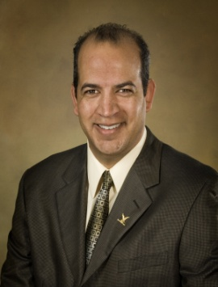
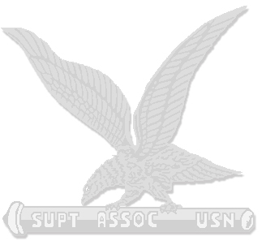
Spring is here and hello to all our current and retired members of NAS. The challenges continues to mount and our leadership abilities are never more needed than now as we continue our service to our fleet and our country. Our country is faced with fighting two wars and a recession that remains consistent. Through all of this, the NAS continues our challenge in providing the care and maintenance to our Navy's ships.
Our primary action as an association is to meet the challenges of providing service to our Nation's fleet. We need to continue to find the ability to provide this service at a high level of quality and maintenance and minimize the cost to our nation. It is a trying task in that our Navy is asked to maintain this tempo with an aging fleet. In addition, our experience in our workforce continues to decrease as many of us are achieving our retirement age and are choosing to go on to our next careers.
So as our Association reaches its Centennial, your National E-Board and Chapter Presidents met for a Mid-Year Convention to discuss our approach and opportunities for leadership in light of all of these challenges. This convention brought forth our resolution to unify under the Chapters for these common goals. By uniting with these goals, we can better exercise our ability to influence our Command's and Navy policies to best work to these outcomes.
Our Centennial Planning committee has been working hard on ideas and concepts to help celebrate this occasion. Each chapter will acknowledge this event, and we will work hard to ensure that our Navy Leadership participates in these events. More news on the National Centennial Event will be coming out soon. Also, please take the time to reach out to our retirees. This will be an important event for all our membership to participate.
The role of NAS National E-board is to represent the chapters and individual members for the good of the Navy. At our Mid-Year convention, we again made that pledge to work to that end. Please feel free to send your thoughts and comments to your local president or any E-Board member.
All my best to you and yours this year.

Dwight Otis
NASNSE National President

